**SQL DDL CONSTRAINTS**

**ASSIGNMENT 2**

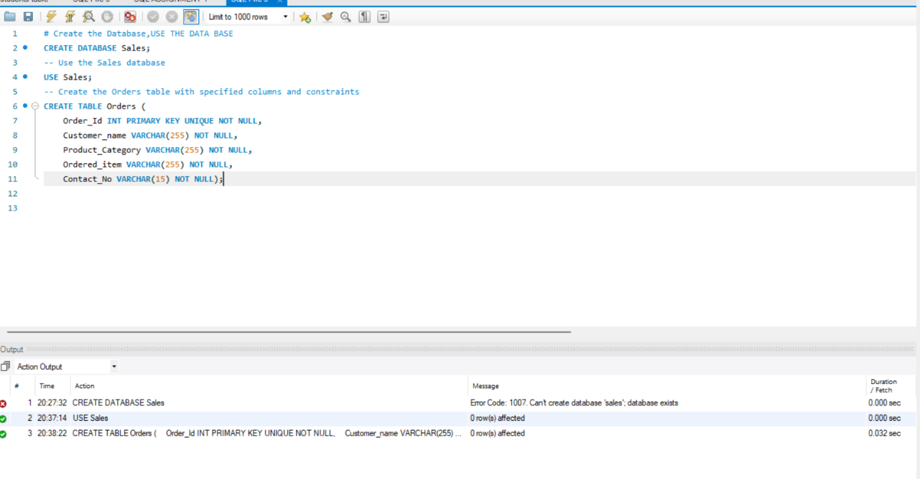

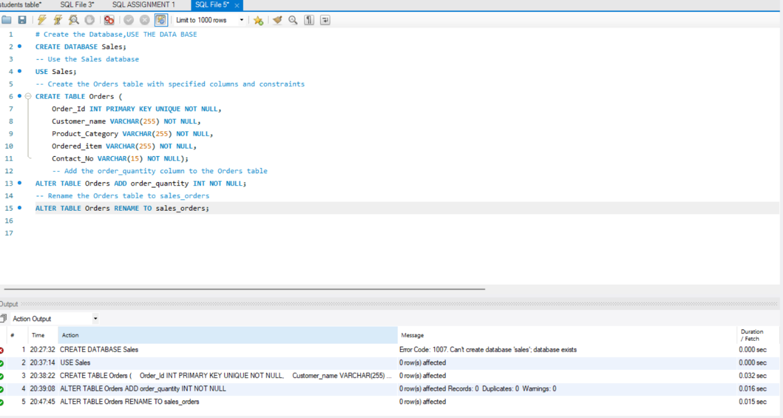

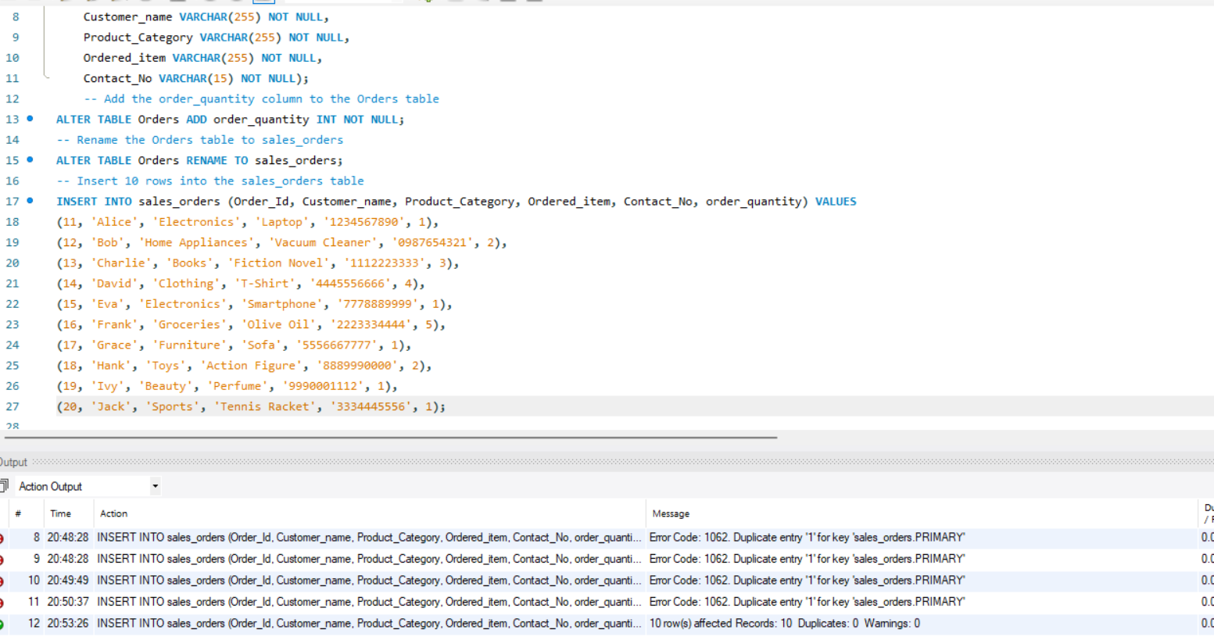

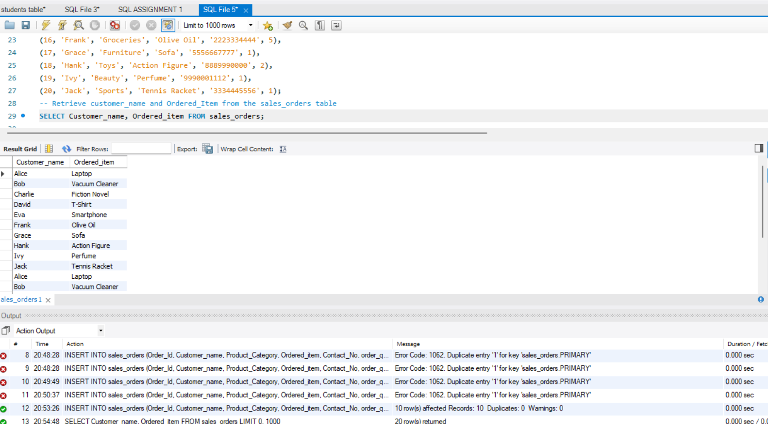

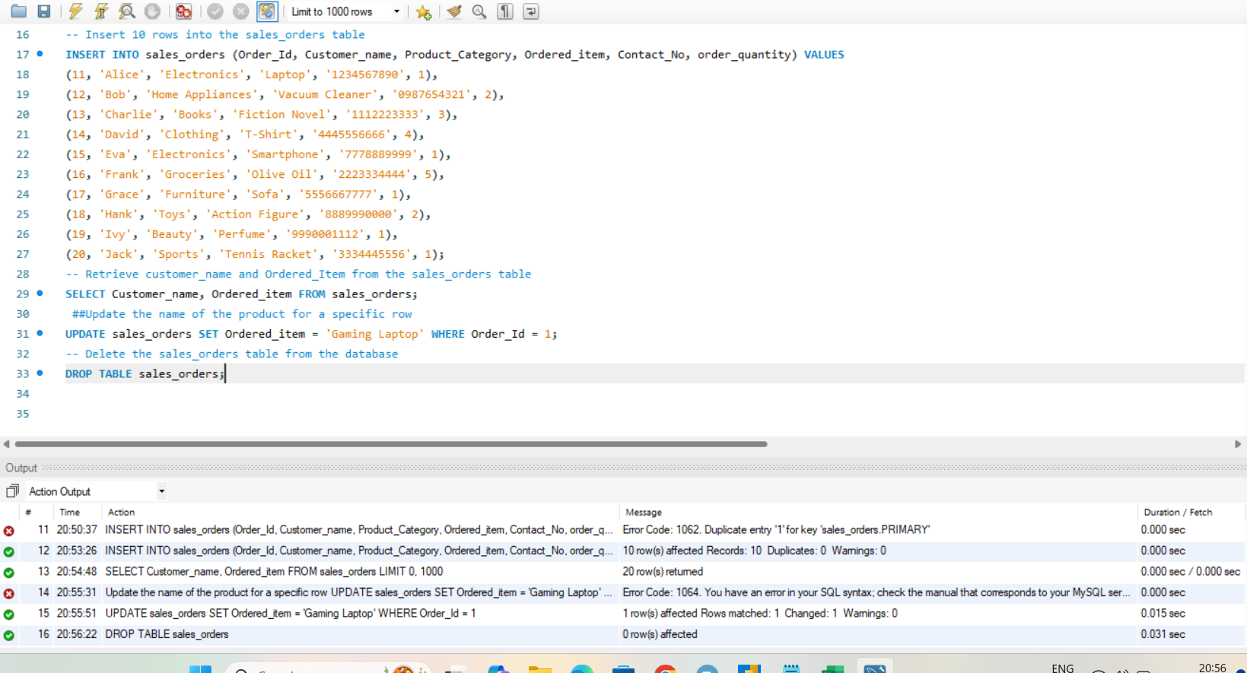

**SUMMERY**

**These commands will create your database and table, modify it as specified, insert data, retrieve data, update a row, and finally delete the table. Make sure you have the necessary permissions and a suitable SQL environment to execute these commands.**